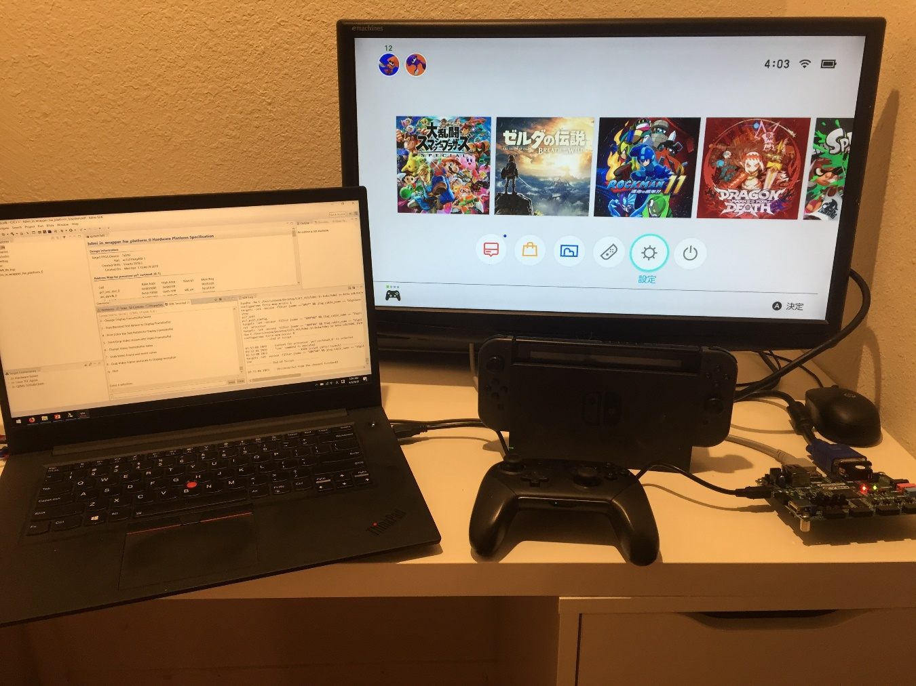

HDMI to VGA Converter Lab Manual

Takatsu Naoaki 015746144

CECS 461 Spring 2019

14, May 2019

1. Install Vivado 2016.4 Edition and SDK from [Xilinx](https://www.xilinx.com/support/download/index.html/content/xilinx/en/downloadNav/vivado-design-tools/archive.html)
2. Follow the steps in the link to download and install “xmdterm.tcl” from [Xilinx](https://www.xilinx.com/support/answers/68503.html)
3. Follow the steps in the link to download vivado-library to use custom IPs from [Github](https://github.com/Digilent/vivado-library)
4. Download HDMI input demo project zip file from [Xilinx](https://reference.digilentinc.com/learn/programmable-logic/tutorials/zybo-hdmi-input-demo/start) and follow all the steps provided
5. Follow steps 1 to 2 for Vivado (not SDK Hardware Handoff) shown on this [link](https://reference.digilentinc.com/learn/programmable-logic/tutorials/github-demos/start) to create and open demo project
6. Go to Project Manager > Project Settings > IP category > Repository Manager. Now click the green plus mark and navigate to the location where you have saved your “vivado-library” folder

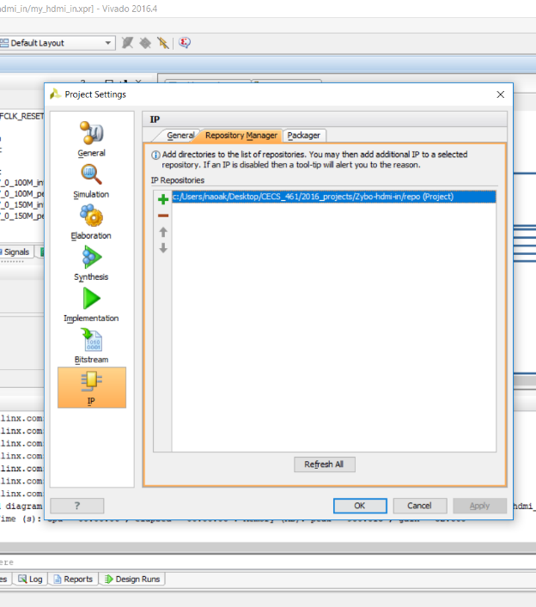

1. Go to Tools > Report > Report IP Status

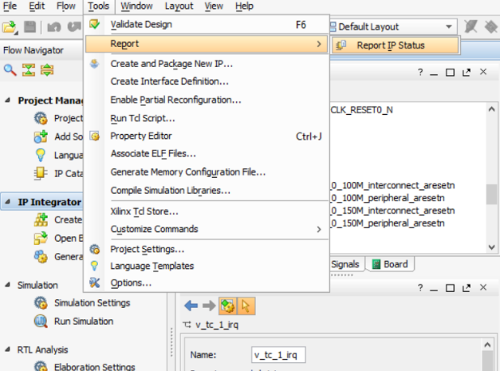

1. Click the Upgrade Selected button on the IP Status tab

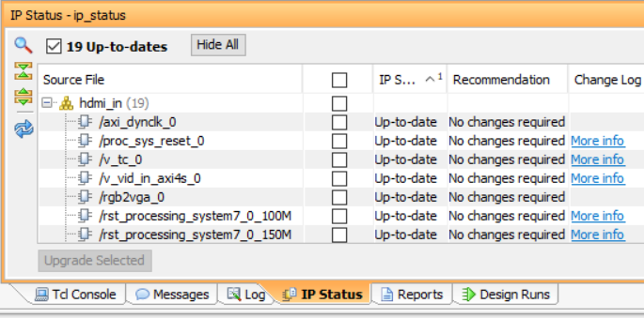

1. *Optional: you may remove GPIO_leds block and its external pin since it’s not used for this project. After removing from block diagram, remove all led related codes from hdmi_in_wrapper.vhd
2. Go to Synthesis > Run Synthesis to run synthesis

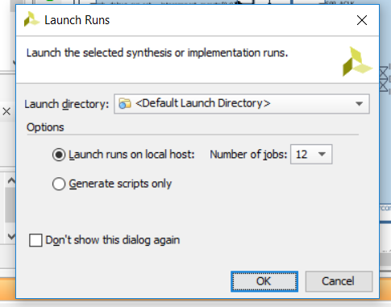

1. Go to Implementation > Run Implementation to run implementation

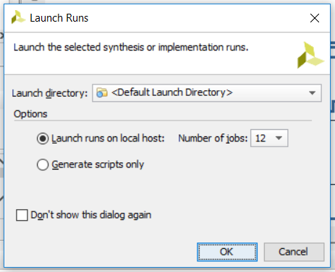

1. Go to Program and Debug > Generate Bitstream to generate bitstream

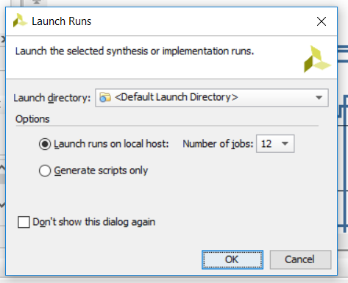

1. Go to File > Launch SDK
2. Remove all unrelated files in Project Explorer tab if necessary
3. Go to File > Import > General > Existing Projects into Workspace and navigate to the sdk folder.

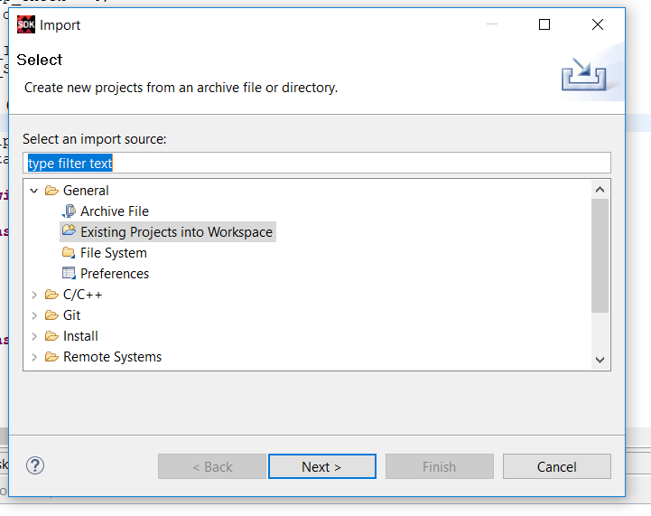

1. Import the HDMI_IN folder
2. Go to File > New > Application Project
3. Type up a name for the application and click Next

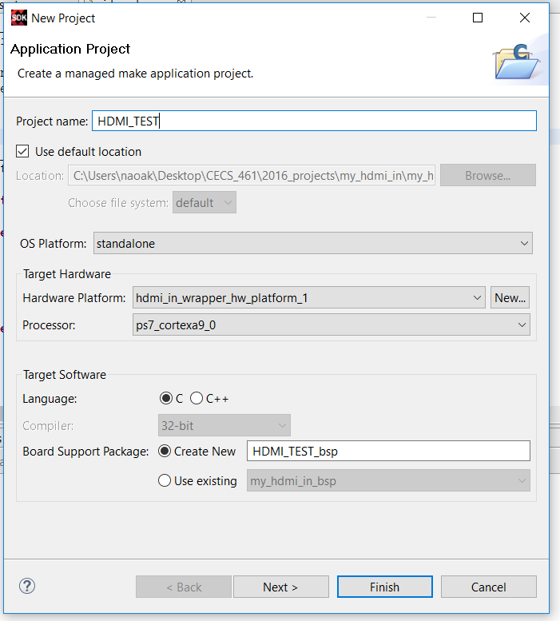

1. Choose Empty Application and click Finish

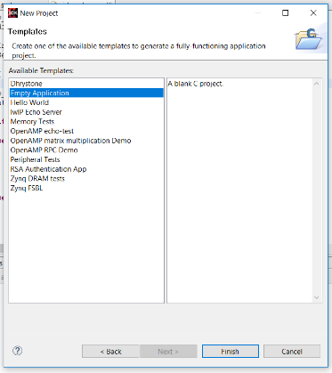

1. Open HDMI_IN > src and copy all folders and C files (excluding files such as lscript.ld, README.txt, and Xilinx.spec)
2. Open your newly created application folder > src and paste the files

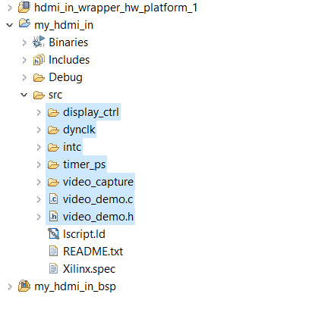

1. Replace the contents for video_demo.c with the provided one or simply close SDK and replace the file itself
2. Click the save all button and check for any error messages. If any error messages show up, try redoing all the steps explained above
3. Connect your Zybo board via micro USB to USB cable and power it on. Makes sure that the 2 header pins are set to USB power and JTAG
4. Power on the board and go to Xilinx > Program FPGA

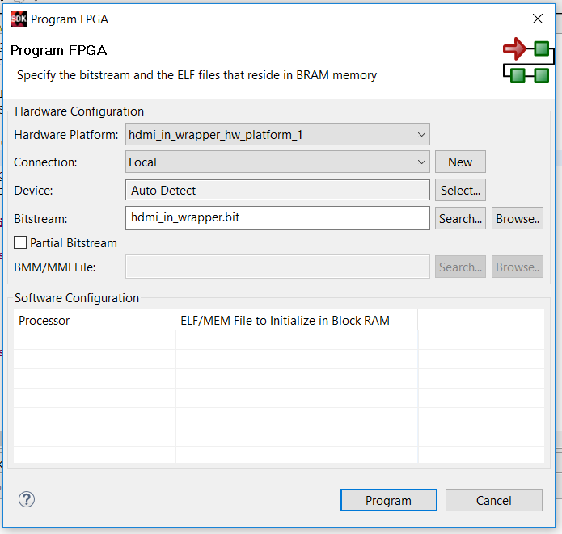

1. Click Program to program FPGA
2. Navigate to SDK Terminal and press the green plus button
3. Select the detected port and enter the following information for the settings

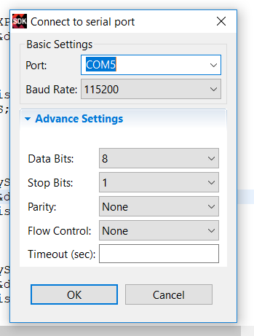

1. Click OK to connect the Zybo board to the terminal
2. Right click your application project and go to Run As > Launch on Hardware GDB
3. Connect HDMI and VGA cables to the Zybo board and the other ends to the HDMI source and display device respectively
4. The display device should show 640 x 480 resolution from the HDMI source by default
5. Review the options shown on the serial terminal and change the dip switch value to adjust the display resolution settings
6. Once the dip switches are set to the proper value, press button 2 on the Zybo board to change the display resolution
7. Test out all the other menus shown on the terminal to see if it works properly
8. Once finished, power off the Zybo Board and unplug the cable from the computer
9. Shut down both SDK and Vivado 2016.4